THE RICHARD STOCKTON COLLEGE
OF NEW JERSEY
STUDENT SENATE

Notice of Meeting
April 2, 2013
4:30 p.m.
Campus Center Board of Trustees’ Room

Pomona, New Jersey 08240-0195 – (609) 652-4845

STUDENT SENATE MEETING
AGENDA

April 2, 2013

- Call to Order/Roll Call

- Approval of Minutes

- President’s Report

- Committee Reports

A. Academic Policies
B. Public Relations
C. Legislative Policies and Government Affairs
D. Student Welfare
E. Finance

V. Announcements/Comments from the Public

VI. Adjournment

2012-2013 Student Senate Meeting
Minutes from
March 19, 2013

Presiding: AJ Vervoort

Members Present: Stephanie Barreto
Becky Batista
Michelle Batista
Ellis Bonds
Peter Bruno
Jessica Carey
Kaitlin Cibenko
Justin Frankel
Melissa Harabedian
Edward Horan
Manar Hussein
William Inacio
Reese Kielty
David Lamando
Melissa Lyon
Kyle Miceli
Matthew Monte
Dave Mooring
Al Nagbe
Chukwuemeka Nnadi
Michelle Puerta

Members Absent: Maribeth Capelli* *Notified Chair
Tyler Gelsleichter
Melissa Harabedian
Nathan Taylor

Members Late: Austin Jefferson

Agenda/Business: AJ called the meeting to order. Senators who were absent or late were noted. Jessica Carey moved to approve the minutes of February 26, 2013 meeting, seconded by Reese Kielty.
Motioned Passed: 21-0-1*
*Senator Abstained: AJ Vervoort

President’s Report: A.J. Vervoort

AJ reported the following:

A.J., David, and Len interviewed for the Senate Office Manager/Secretary position on Monday, March 4th. Our new secretary is Victor Belisle.

A.J. registered Stockton as an LGBT friendly campus on Campus Pride’s Index of college campuses. After a few months of waiting we were approved and received 4.5 out of 5. This puts us 3rd in the state and battling for 12th in the tri-state region. Special thanks to Pedro who assisted me with the Human Resource aspect of the process.

A.J. met with Craig Stambaugh, Associate Dean of Students, and Laurie Griscom to rearrange the Board room to better suit the electronic minutes change.

A.J. was the trip coordinator to LegCon. Justin Frankel, Pete Bruno, Maribeth Capelli, and Jess Carey attended.

The e-board met on Thursday, March 7th to discuss financial changes to the Senate for next year. The finance committee recommended and the executive cabinet approved not to fund the resource room next year.
A.J. is still waiting to hear if we were approved for the requested $50,000 increase to be added to student clubs for next fiscal year.

A.J. met with Pedro Santana, Dean of Students, on March 6th, to go over weekly issues and recommend a commuter lounge. Maribeth is working on the proposal now and scoping out locations.

A.J. and Justin met to develop how to proceed with appointing and nominating someone to the New Jersey United Students Board as well as the Higher Education Student Assistance Authority Committee (HESSA) under the governor’s office.

Stockton is currently eligible for 2 representatives on HESSA and we want to ensure Stockton is represented in future years.

A.J. has been in close contact with Claudine Keenan and the Faculty Senate on University Status.

A.J. went over the 2012 LGBTQ National College athlete Report with the Office of the President on March 12, 2013.

Special thanks to the Public Relations committee who did an excellent job hosting meet the candidates this year.

Vice President’s Report: David Lamando

David reported that the Inter Club Council went well, and that all the budgets are finished being reviewed by the finance committee.

Matt Monte reported that he personally met with Mike Wood about the $50,000 increased requested by Senate for student clubs for the next fiscal year. He apologized for not consulting with his committee or anyone else on Senate. He said that within the confines of that particular meeting he was representing his own opinion, not the opinion of Senate. It is his opinion that the supplemental fund should not be increased by any means due to the fact that clubs currently mismanage their money and spend it on frivolous things with their current budgets, and that this projected $50,000 go back to the students by other means.

AJ disagreed with Matt. Manar requested that we need to better communicate as a Senate, being that we represent the voice of all students. Jessica agreed with Manar, and stated that we as a Senate need to work better with Student Development to better educate club’s executive boards on how to appropriately use their allocated club/organization funds.

Austin arrived at this time.

Manar reemphasized the need for better communication. Melissa suggested that the executive board of Senate as well as the president and vice president have more transparency with the rest of the senators.

Kaitlin moved to end discussion. Chukwuemeka seconded the motion.

Motion passed 22-0-1*
*Senator Abstained: AJ Vervoort

Committee Reports: Public Relations

Stephanie reported the following:

The committee is working on reminding candidates about upcoming deadlines and events, relative to elections, via E-mail and social networking.

The last town hall meeting of the semester will be on March 28th in the CC Theatre. Please attend to get a chance to voice your opinion, have your questions answered, and indulge in FREE food! Senators please wear your polos.

March 18th is the new date in which candidates could turn in their campaigning materials to the Office of Student Development.

The Care Program, Verizon, the Wellness Center, and Student Senate are partnering up to provide emergency contact support to domestic violence victims and survivors. The collection consists of no-longer-used wireless phones and accessories. The Collection will start on March 18 through March 22, 2013. Drop off boxes can be found in the main campus outside the Richard J. Bjork Library, rooms F-107 and J-204, and inside room Q-212 (2nd floor), Student Development Resource Room and the Campus Center. Any donation is most appreciated!
Academic Policies

Becky reported the following:

The senators approved the following amendment:

Student Senate Statutes
Mission Statement
The Student Senate is the governing entity of the clubs and Organizations affiliated with The Richard Stockton College of New Jersey; it is a representation of the student population. In addition, the Senate is responsible for reviewing requests for allocations of funds from the college activity fee fund and for recommending to the Dean of Students such allocations.

Legislative Policies and Government Affairs Committee

Justin reported the following:

He gave a brief summation of the Legislative Conference that he attended with Peter, Maribeth, AJ and Jessica. He personally recommended that we discontinue associate with USSA for the conference, but noted that we continue to support NJUS.

During the committee meeting, the committee members met with NJUS and discussed the various forms of Student Government present at other schools such as Rowan, Montclair, University of Wisconsin and Rutgers. We went over various ways in which these governments compare and contrast to our structure.

Tyler is meeting with Dr. Figart on March 20th to continue developing the Financial Literacy program that Len Farber has introduced to him.

Jessica and Tyler are finished their research on tuition increases and reported the information during the meeting via a powerpoint presentation.

Justin has set up a meeting with Senator Whelan for March 27. They will be discussing ways students can be proactive in lobbying the legislature for more monetary aid. Justin is waiting to speak with Mr. Klein, president of NJASCU to discuss details of Governor Christy’s budget proposal and formulate an action plan.

Dave is working on setting up a meeting with President Saatkamp and possibly the Board of Trustees to discuss what the committee and Senate can do in order to secure the maximum amount of funding from the Bond Referendum that was passed last year.

Jessica reported the research that she and Tyler have been conducting on tuition increases. The following images are a summary of her presentation: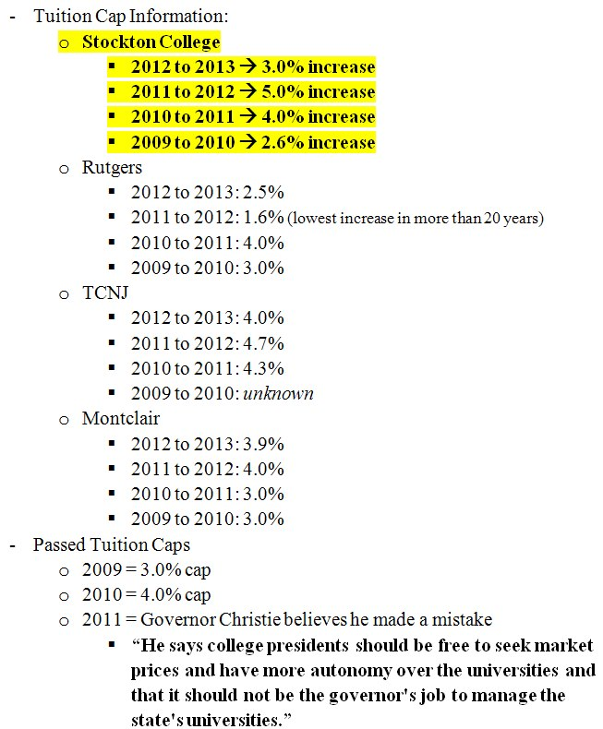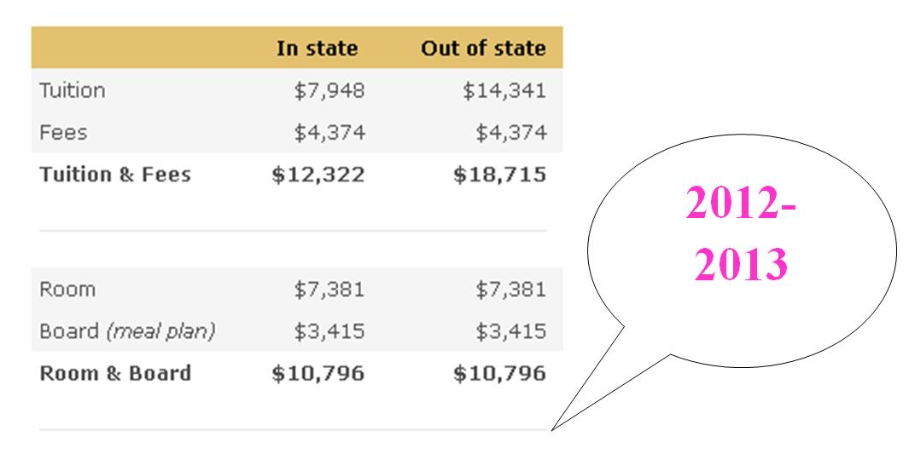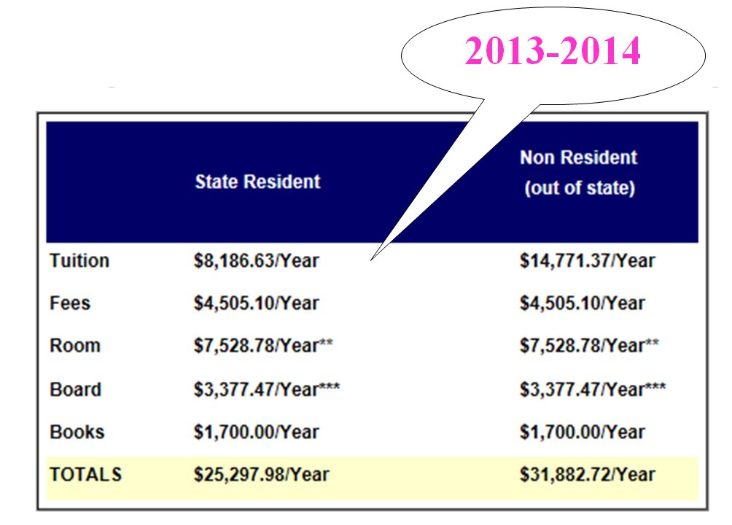

Student Welfare

Ben reported the following in Maribeth’s absence:

Stephanie and Peter left at this time.

Commuters are still requesting to have their own lounge. The committee is looking into different options that we are considering. We are also waiting to hear back about what locations are possible to put a lounge. We are also going to look into collaborating with the Wellness Center to make the lounge a stress free and relaxing getaway for students. I met with Pedro Santana, Dean of Students, and Craig Stambaugh, Assistant Dean of Students, regarding the issue and they are working to make it possible.

A student suggested that Chartwells subsidize the food it sells at Lakeside, specifically healthy food choices and milk. The committee is going to look into what we can do about lowering milk prices first.

The committee has a meeting with Denise O’Neil, Director of Residential Life on Friday. She gave us some updates. The new housing selection process that was created by the Housing Selection Feasibility Committee that Maribeth served on in the fall is doing wonderful. They had over 90% of returning students participate in the new housing selection process meetings. Also, students had requested to be able to use their meal plan over spring break. Unfortunately, they are not able to use meal swipes, but they can now use their flex money to purchase food. We also have over 300 students staying on campus over break including 8 at Seaview. Denise is looking into getting shuttle transportation for Seaview students over break for next year.

The committee presented some issues to Denise. The geese issue has not been resolved because Plant Management cannot find a good enough preventative plan. However, the committee will be attending a meeting next week with Denise and Plant Management to discuss alternative path clearing methods so that next year when the geese population returns we can keep the walkways clear.

Students in Housing V are having a few issues. The hot water in Nectar and Maple has not been working properly. Plant Management is doing everything they can to fix the problem right now, but it is reoccurring and possibly a larger issue that needs to be address over the summer when residential areas are vacant. Kyle Miceli is researching what showers those students with hot water problems can currently use and when. He will be collaborating with Denise on how to get that information out to the students. Also, some students had issues with the building settling and cracks appearing in their walls. Denise is looking into this to make sure that the cracks are not compromising safety, and Plant Management has been taking care of it also.

Eddie is continuing to keep in contact with Joe Loefflad regarding e-mail and WiFi issues. A student was concerned about the virus protection the e-mail system may or may not provide.

Ben is keeping in contact with Don Woolslayer, Director of Plant Management about various issues. Students are still complaining about the parking lot in A&S circle. Although the lot is leveled every year, there still needs to be up keeping done that is currently not being done.

Finance

Criminal Justice Society submitted a supplemental in the amount of $925.00 in order to fund their trip the State Police Museum. The club needs a bus for their 30 members. Matt moved to approve the supplemental, seconded by Kaitlin.

Motion passed 1-18-1*
* Senator in favor: Becky Batista
Senator abstained: AJ Vervoort

Equestrian Club submitted a supplemental in the amount of $1,365.00 in order to provide the club with more riding lessons. Matt moved to approve the supplemental, seconded by David.
Motion passed 19-0-1*
*Senator Abstained: AJ Vervoort

C.O.O.L (Formerly Idols of Tribe), submitted a supplemental in the amount of $1,247.52 in order to fund their trip to Sigma Tau Delta Convention. Matt moved to approve the supplemental, seconded by Melissa Lyon.

Motion passed 17-2-1*

*Senators Opposed: Austin Jefferson and Ben Peoples
Senator Abstained: AJ Vervoort

African Students Organization submitted a supplemental in the amount of $1,550 in order to fund Afahyε: A night of African Dance and Drum presentation. This event will be open to all students. Matt moved to approve the supplemental, seconded by Ellis.

Motion passed 19-0-1*
*Senator Abstained: AJ Vervoort

Computer Society submitted a supplemental in the amount of $1,055 in order fund their trip to the AITP National Collegiate Conference. Club members will represent Stockton by competing at the conference. Matt moved to approve the supplemental, seconded by Kaitlin.
Motion passed 19-0-1*

*Senator Abstained: AJ Vervoort

The following clubs had their budgets reviewed, African Student Org, Communications, All Starz, Books w/o Borders, Criminal Justice, Dance, Equestrian, FEMALES, Gaming Club, Greek Council, International Business, Los Latinos Unidos, Unified Black Student Society (UBSS), Hospitality and Tourism, MALES, Marine Science, Debate, EDIBL, Animal Friendly CSA, SET, Step Explosion, Model UN, Health Services and Economics.

Clubs that failed to attend: Accounting, Anime, Art, Campus Marketing, Chemistry, BLAST, Computer, G.E.R.O.S, Multi-Cultural Connection, Step EXPLOSION, Health Services, All Class Councils and Highest Praise Gospel Choir.

Review Dates Left

March 26th – Occupational Therapy, OGRE, Psychology, Public Health, Social Work, Speech and Hearing, STAND, On the Go, Peer Educators, Pride Alliance, Theatre, Water Watch, Hope, Idols of Tribe, Stockton Neighborhood Watch, Political Science, Argo, Campus Religious Council, Resource Room, Stock-Apella, Stockton Nursing, Hero, Student Veterans, Hollistic Health

March 26 - Finance Committee finalizes allocations and reports amount to the individual clubs.

April 9 – Clubs appeal to the committee. Committee votes on the total budget allocation.

April 16 – Full senate votes on the total budget allocation.

Announcements/Comments from the Public:

There were no comments from the public.

Adjournment: AJ adjourned the meeting at 5:53 pm.

