How to Register/Log in
- Open your Internet Browser (Internet Explorer, Firefox, etc.). Click on the following link, or copy and paste it into the web browser:

https://www.myschoolbuilding.com/myschoolbuilding/mygateway.asp?acctnum=220207010

In addition, this link is also available by accessing the Office of Facilities and Construction’s SchoolDude Work Order webpage (search the phrases “work order” or “schooldude” from the Stockton University homepage).
- If you are a returning user, enter your Email Address and Password. If you have not previously selected a password, please use – newuser. Click Sign In.
- If you have forgotten your password or are unsuccessful to login using the password newuser, click the Forgot Password? Link and enter your email address. We’ll email you instructions for resetting your password.
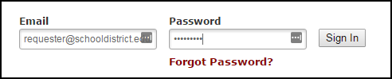
- If you are submitting your first request, you must enter registration information first. *Note: Your registration will be complete after you submit your first work request.
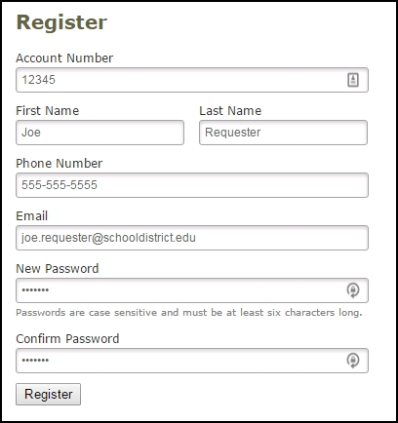
- Enter the Account Number provided by your Administrator - 220207010
- Enter your First and Last Name, as well as your Phone Number and Email Address.
- Type the Password you would like to use to log into your SchoolDude account and confirm it. The password you choose must be 6 characters long.
- Click Register to go to the work order request form.

How to Submit a Request
- Make sure you are on the Maint Request tab at the top of the screen.
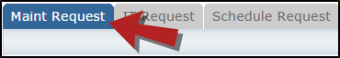
*Note: Any field marked with a red checkmark is a required field.
- Step 1: These fields will already be filled in with your contact information according to how it was entered upon registration.
- Step 2: Click on the drop down arrow and highlight the Location where the work needs to be done. Do the same for Building (if available) and Area. Also, be sure to type in the area description or room number in the Area/Room Number field.
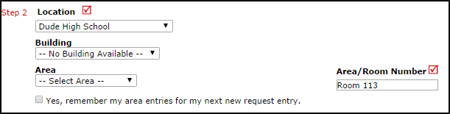
- Step 3: Select the Problem Type that best describes the request/issue you are reporting.
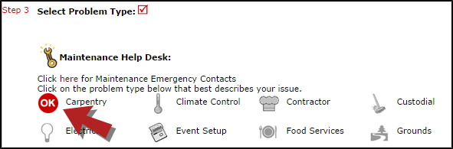
- Step 4: Type in a description of the problem.
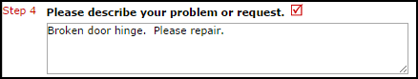
- Step 5: Attach a file to your request if necessary (i.e. a picture of damage or setup diagram).
- Step 6: Type in the Submittal Password - stockton
- Step 7: Click the Submit button.

My Request Tab
You can view any requests that you have entered into the system by clicking on the My Requests tab. Hover your mouse over the Shortcuts link and click on My Maint Requests. You will see a listing of any requests that you have entered into the system. You are also able to print out a listing of your requests by clicking on the printer icon.
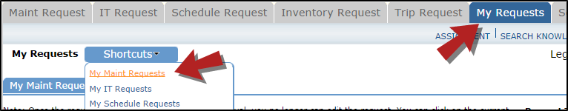
On the My Requests page you will see up-to-date information on your requests including the current status, work order ID number, and Action Taken notes. You can click on the number next to the status description in the Request Totals section to see all of your requests marked with that status. You can also search for any work order request by typing a key work into the Search box and clicking Go.
