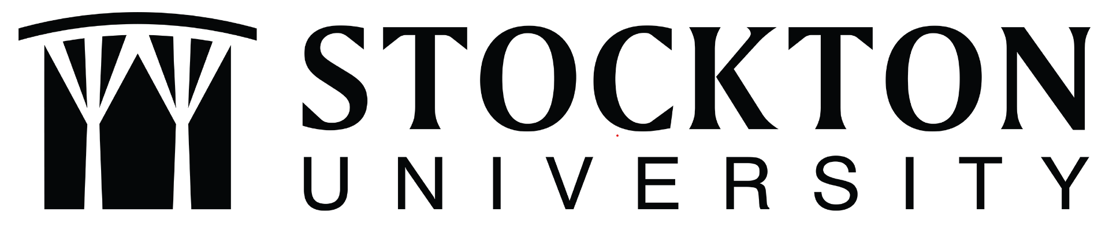

Student Learning Outcomes Assessment
Program Workbook
(Name of Program)

Dear Program Faculty,
As the Director of Academic Assessment at Stockton University, it is my pleasure to guide you through the process of Student Learning Outcomes Assessment. The university conducts student learning outcomes assessment for all programs offered by the university on a systematic and sustainable basis. This workbook is designed to help facilitate the assessment process through a “one stop shop.” Everything you need to complete your Program Annual Report can be found here
Perhaps the most important thing we’d like to convey is that the Office of Academic Assessment is here to support you through every step of the process. The best assessment is always collaborative in nature! The Academic Assessment website contains a variety of resources to guide your assessment journey, and team members are available to answer any questions you may have. We look forward to working with you in the spirit of assessment excellence and continuous improvement.

Alaina Walton
Director of Academic Assessment
Alaina.walton@stockton.edu
609-626-5876
B-106c

Programmatic Assessment
At the programmatic level, the university follows a systematic model for the assessment of program-level student learning outcomes. Within this model, all program-level student learning outcomes can be assessed once within a four-year cycle.

Program-level Student Learning Outcomes (See Program Annual Report Template C)
Please review the program-level student learning outcomes that your program is currently using for assessment. If you would like assistance in creating or modifying program-level student learning outcomes, the Director of Academic Assessment is happy to work with you.
Graduates of this program will be able to:

4-Year Program-Level Assessment Plan
(Name of Program)

Please copy/paste individual program learning outcomes under the years in which you’d like to focus on them. Ideally, each program learning outcome can be assessed once every four years. Faculty may choose to focus on more than one outcome per year if the program has more than four program learning outcomes. (See Program Annual Report Template C.1)

AY 2021-2022

AY 2022-2023

AY 2023-2024

AY 2024-2025

AY 2025-2026

Curriculum Map
(See Program Annual Report Template C.1)

Academic Assessment Plan
AY 2021 – 2022

Contact Person:
School:
Program:

Outcome(s)

Program-level Student Learning Outcome(s): (Example: PLO #
(See Program Annual Report Template C.2)

Assessment (See Program Annual Report Template C.3)

Course: (Example: ENSC 5402: Professional Writing)

Means of Assessment: (Example: Final Lab Report).

Criteria for Success: (Example: 80% of participating students will score at least 7 out of 10
points on the section of the rubric entitled “Professional Writing”).

Results (See Program Annual Report Template C.3)

Data: (Example: 7 out of 9 students, or 77.7% of students, scored at least 7 out of 10 points on
the Professional Writing section of the Final Lab Report. Criterion met).

Reflective Summary: (Example: We have recently increased the number of smaller writing assignments, which offers more opportunities for students to practice their writing. This has helped students become more confident in their writing skills).

Action Plan (See Program Annual Report Template C.4)
As a result of the assessment, what actions will take place in the next academic year?
(Example: Add one or two additional small writing assignments closer to the Final Lab Report).

Continuous Improvement: Use of Assessment Results from Previous Year

AY 2010-21 (See Program Annual Report Template C.5)

Program Learning Outcome from previous year:

Course from previous year:

Planned Improvement:

Implementation and Results:

