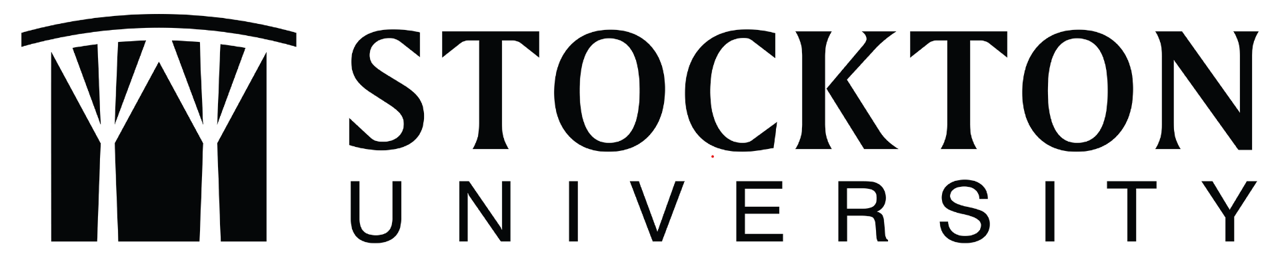

Student Learning Outcomes Assessment
Program Workbook
(Name of Program)

Dear Program Faculty,
As the Director of Academic Assessment at Stockton University, it is my pleasure to guide you through the process of Student Learning Outcomes Assessment. The university conducts student learning outcomes assessment for all programs offered by the university on a systematic and sustainable basis. This workbook is designed to help facilitate the assessment process through a “one stop shop.”
Perhaps the most important thing I’d like to convey is that the Office of Academic Assessment is here to support you through every step of the process. The best assessment is always collaborative in nature! The Academic Assessment website contains a variety of resources to guide your assessment journey, and I am always available to answer any questions you may have. I look forward to working with you in the spirit of assessment excellence and continuous improvement.

Dr. Alaina Walton
Director of Academic Assessment
Alaina.walton@stockton.edu
609-652-4624
B-106c

Programmatic Assessment
At the programmatic level, the university follows a systematic model for the assessment of program-level student learning outcomes. Within this model, all program-level student learning outcomes can be assessed at least once within the six-year periodic program review cycle.

Program-level Student Learning Outcomes
Please review the program-level student learning outcomes that your program is currently using for assessment. If you would like assistance in creating or modifying program-level student learning outcomes, the Director of Academic Assessment is happy to work with you.
Graduates of this program will be able to:

6-Year Program-Level Assessment Plan
(Name of Program)

Please copy/paste individual program learning outcomes under the years in which you’d like to focus on them. Ideally, each program learning outcome can be assessed once every four years. Faculty may choose to focus on more than one outcome per year if the program has more than four program learning outcomes.

AY 202-2022

AY 2022-2023

AY 2023-2024

AY 2024-2025

AY 2025-2026

Academic Assessment Plan
AY 2022 – 2023

Contact Person:
School:
Program:

Outcome(s)
What Program-Level Student Learning Outcome(s) did I focus on this year?

Assessment
What course did we use to assess the program-level student learning outcome?

What assignment within the course did we use as the means of assessment?

How will this assessment show me that the program-level student learning outcome is being met?

Results
Record the results of the assessment:

Reflective Summary
What did I as the instructor learn from giving this assessment?

Action Plan
As a result of the assessment, what actions will take place in the next academic year?

Continuous Improvement: Use of Assessment Results from Previous Year

AY 2021-22

Program Learning Outcome from previous year:

Course from previous year:

Planned Improvement:

Implementation and Results:

